# Lab Week 2. Conditionals & Loops

## Learning Objectives

* Using For Loop
* Local variable – for loop counter
* Using Nested loops

## Resources

* Lecture Notes
* Processing website – reference
* <https://processing.org/reference/for.html>

**Exercise 1**. Improve the code below, make it more concise and easier to read

size(200, 200);

line(20, 0, 20, height);

line(40, 0, 40, height);

line(60, 0, 60, height);

line(80, 0, 80, height);

line(100, 0, 100, height);

line(120, 0, 120, height);

line(140, 0, 140, height);

line(160, 0, 160, height);

line(180, 0, 180, height);

**Exercise 2** Enter the code below, and run it

int x=10; //declare int variable called x put 10 in there

int y=20; //declare int variable called y put 20 in there

size(100,100); //set size of canvas screen

for(int i=0; i<5; i=i+1)

{

x=x+10;

print(" i:"+i+",x:"+x); //display variable value in console window

ellipse(x,y, 5,5);

}

1. Enter the code precisely as above, and run. Note the print command, prints the value of local variable **i** and global variable **x** to the console (bottom of sketch window)
2. 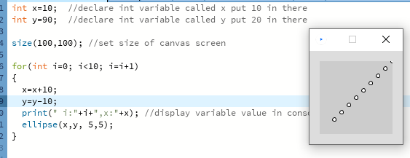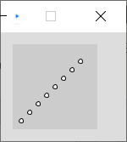Alter the code so we get a horizontal line of 10 circles on the screen. You may have to increase the size of your canvas.
3. 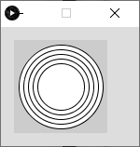Alter the code to get the image, see right 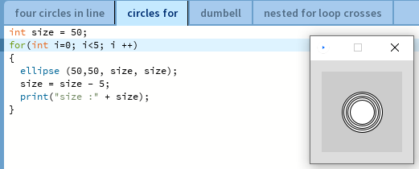

D. Write a new program so that you get 5 concentric circles in the middle of the canvas, see image

**Pair Programming Exercise**: How do we code this? Design then code.

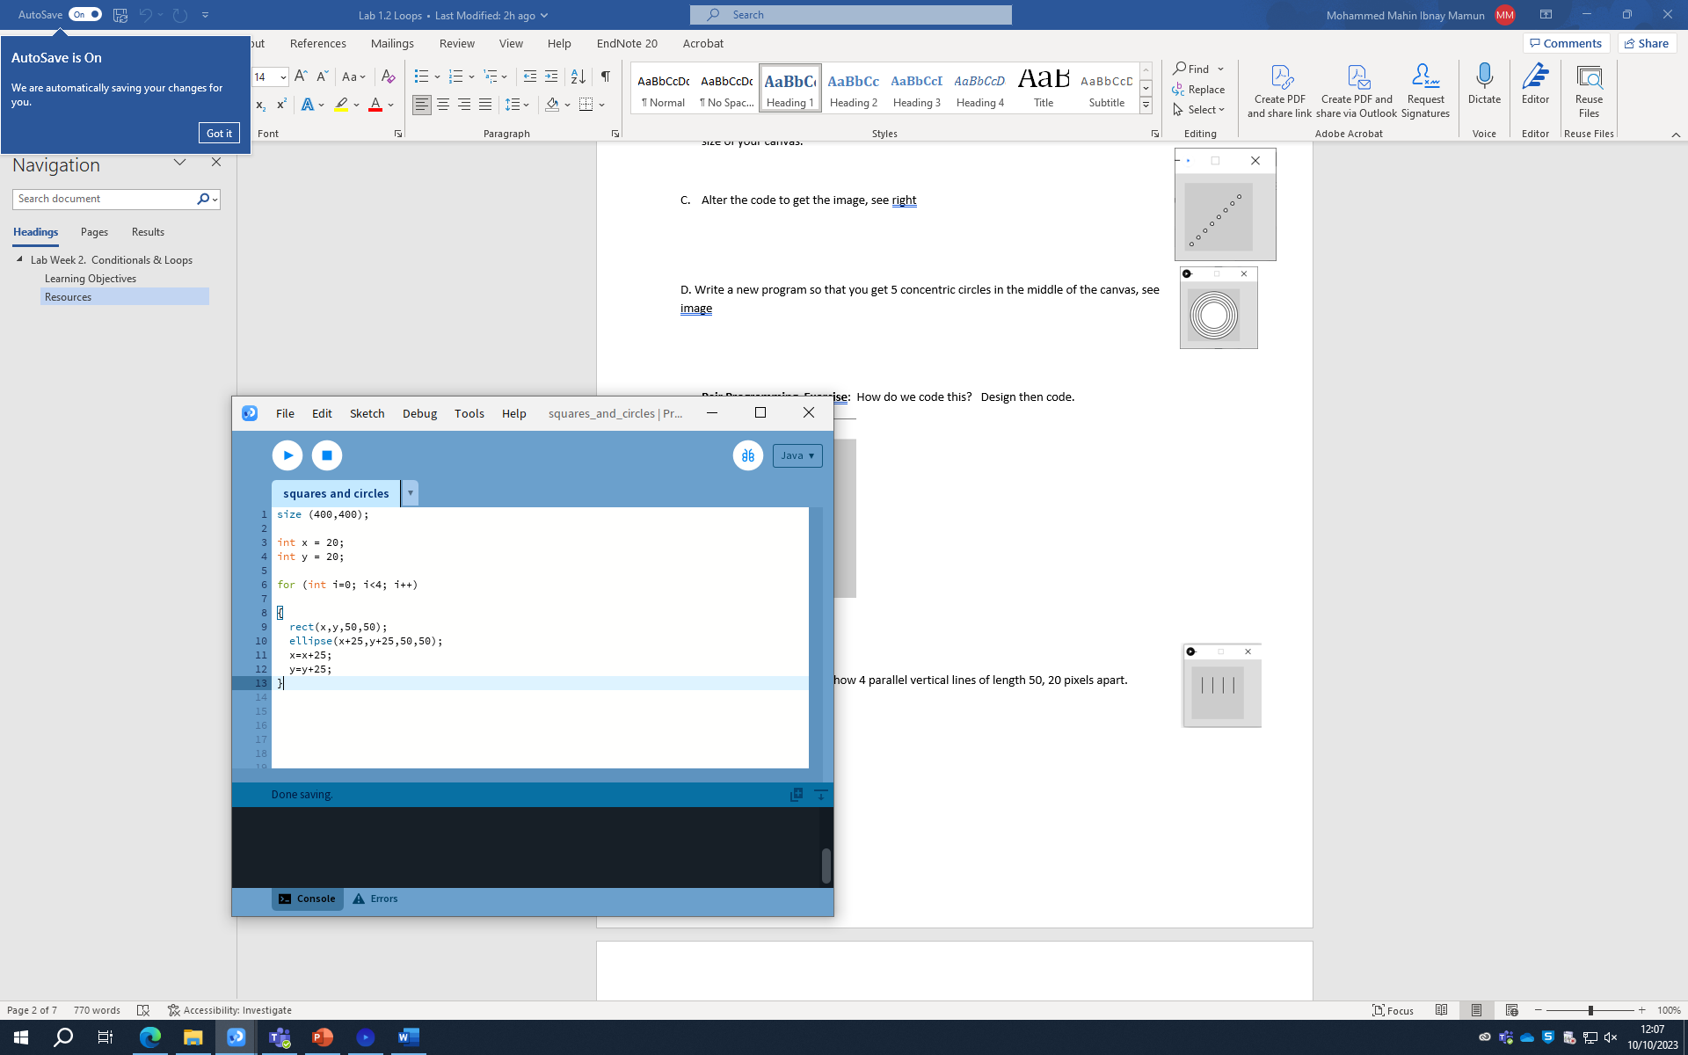

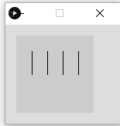

**Exercise 3**. Produce code to show 4 parallel vertical lines of length 50, 20 pixels apart.

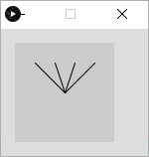

B. Write code to produce, this pattern. Note this is similar to the previous problem, but the end points of all the lines are the same.

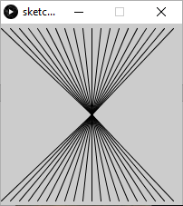

C. Produce a design for this pattern – comments at the top of a new sketch

Turn your design into code.

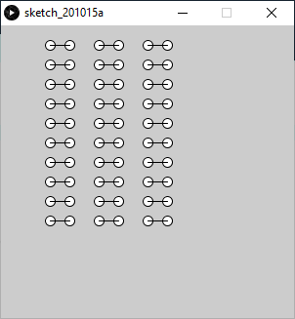**Exercise 4. Design and code**

A Good solution should show evidence of the design as comments, use all concepts covered so far. Best solutions will allow easy rescaling and repositioning of the pattern.

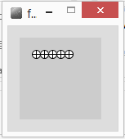**Exercise 5.** Design and code a program to show a row of 5 wheels

Design and code a program to draw 10 wheels in a vertical column

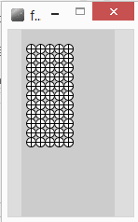Alter your program code so we get a block of wheels – 5 wide, by 10 deep

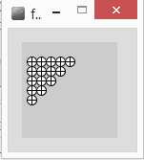

**Exercise 6**. Produce a program to draw each image

Hint – use a variable to control how many repetitions a loop performs

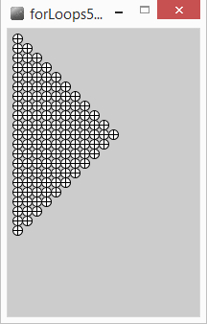

**Exercise 7.** Try out the code below, what does it do and why?

float x= 25;

float y=25;

float radius = 20;

float angle; //in radians

for(int degrees=0; degrees<360; degrees = degrees+10)

{

angle = **radians**(degrees); //convert degrees to radians

**line**(x,y, x+radius\***sin**(angle),y+radius\***cos**(angle));

}

Put the code below into the for loop to change the colour of each ‘spoke’.

float r = **random**(50); //random number [0..50]

float g = **random**(50);

float b = **random**(50);

**stroke**(r*5,g*5,b*5); //random line colour

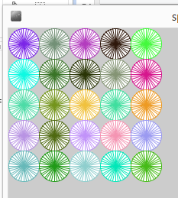

**Exercise 8**. Pop Art Wheels, a 10 by 10 block of wheels, each of a different random colour

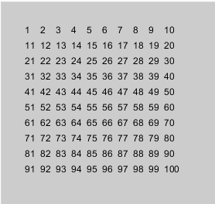**Extension exercise 1**.

text("*", 100,100); //draws a text string ‘*’ at position 100,100

int count=10;

text(""+count, x,y); //draws value of count at x,y

draw the image, left.

**Extension Exercises 2.**

Write code using the **print** command to display a result for each of the following problems:

1. Display the sum of all the integer number in a specific range (use two variables to define the start and end value), e.g sum of values between 10 and 13 is 10+11+12+13 should display **46**

Check your solution works no matter what values are used for the variables.

1. Factorial 3 is equal to 3 * 2 * 1 resulting in 6, Factorial 5 is 5 * 4 * 3 * 2 * 1

Write some code to display the result of factorial x, where x is a variable

1. X to the power of 2 is X * X, to the power of 4 would be X * X * X * X, write code to show the result of X to the power of Y, where X and Y are variables.
2. y = 2x + 5 is a simple linear equation, use a loop to provide values for x to plot a graph of this equation (note it will be inverted y is further down the screen as the value increase).
   1. Using some simple Maths alter your graph plotter so that the origin appears to be bottom left corner, y is 0 at the bottom of the screen
   2. Introduce variables to allow different graphs to be plotted with different constants.

**Extension exercise 3.** (optical illusion), needs an if statement and a Boolean variable ( a flag )

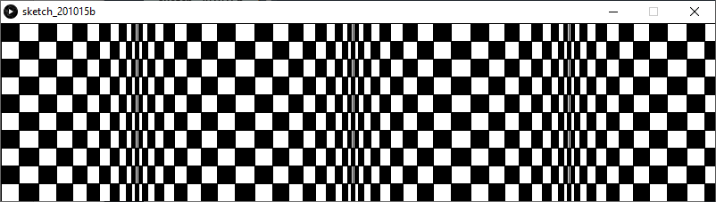

Continue with tutorials on the Processing website